THE HIDDEN RURAL HOUSING CHALLENGES IN ETHIPIA
AND
AN ALTERNATIVE MITIGATION MEASURE
By
Kassahun Admassu Abegaz (PhD)
Abstract
Though the degree of severity is staggering the challenge of housing is evident globally. The dilemma faced by any state operator is how to balance and harmonize the human habitat development and limited resources in equity. Many nations enshrine housing development in their policy with a strategic plan framework; country wide; to keep every citizen on board. In some, such practices do happen rarely. In which case, a certain segment of the population will be left far behind. For such states the wake-up call may be felt very late; by which time, situations might have gone far beyond reversibility by any remedial measure. In Ethiopia , the housing situation in the rural was not given a policy coverage (if not mistaken) until the GTP I and GTP II plans, where it stated that, rural housing is 3,400,000 and the urban including Addis Ababa is 1,500,000 within the period of 2015/16-2020/21; per the 2014 Ministry of Urban Development and Housing Construction (MoUDHC) report. Though not sure of the progress made, time is speeding up. To straighten up the ambitious popular plan, specifically, that for the rural domain, available alternatives have to be critically evaluated. One of such alternatives could be amended compressed earth block (ACEB). The research postulated as: “amending a given natural soil with lime and powdered pozzolans in the presence of optimal amount of water could be an improvised building material” had achieved a positive result both in compressive strength and durability (water attack) terms; in reference to international earth construction normative. It is thus, jugged as a better performing wall making block and mortar for earthen construction. The lengthy process has gone through the following three profound phases; intensive laboratory synthesis, public outreach pilot project construction, acquire a patent confirming an innovative construction product and publish a paper in a scientific journal of international reputation to herald the success. This article is presented here to introduce the finding that could be a catalyst in alleviating the housing and environmental challenges that Ethiopia is going to face by 2050. The paper covers the progress made so far and provokes with a plan to promote the ACEB construction input at a small scale production level; and thereby, to stand as an environmental steward for the highly coveted flagship of “ETHIOPIA 2050 – Grand Challenges & Opportunities”.

Keywords: Rural housing, Amended compressed earth block, Environmental challenges, Alternative, pozzolans
__________________________________________________________________________________
INTRODUCTION
Since time immemorial the human society was completely dependent on raw natural resources to fulfill all its construction material needs. Through years, thanks to the emergence of science and technology this has very much changed; but still with immense drawbacks. The real challenge being faced is how to balance and harmonize the human habitat development and the naturally endowed resources. In this regard, fulfilling the highly needed living and work place infrastructures both in terms of equity and comfort is a daunting challenge. To date, people have tried so many ways and means with regard to manufacturing construction materials. Under all circumstances, the bottom line of the success needed is the manufacturing and availing of affordable and sustainable construction materials with due regard to the environmental care.
In the Ethiopian context, searching for affordable construction materials is at its crucial stage; if not overdue. In the long history of our housing culture raw natural resources with little or no processing were dominant. But through time, since those resources are getting scarcer other means ought to be looked for. In this respect, the initiation of this research is to launch a long lasting and continuous research aiming at our own local habitat culture, building materials, building forms, climatic conditions, endowed resources, etc. to ameliorate a home grown and sustainable earth based and affordable housing construction technology and culture.
As to earth based construction, from 1979 to 2010 ninety one earth standards were put in use worldwide. Out of those; African Regional Standard Organization (ARSO) were 14, Brazil (NBR) were 13, Burkina Faso (NBF) were 8, Cameroon (NC) were 14, Colombia (NTC) was 1, EEUU (NMAC & ASTM) were 1 each, France (XPP) was 1, India (IS) were 3, Italy (Ley & L.R.) were 1 each, Kenya (KS) was 1, Nigeria (NIS) was 1, New Zealand (NZS) were 3, Peru (NTE & NTP) were 4, Senegal (NS) were 14, Spain (NNE) was 1, Sri Lanka (SLS) were 3, Tunisia (NT) were 2, Turkey (TS) were 3, and Zimbabwe (SAZS) was 1; [1]. The documents are really worth to be introduced and reckoned with before embarking on the details of the forthcoming coverage
CONTEXTUAL UNDERSTANDING AND METHOD
The local building construction materials are mostly defined by the geographical location and settlement pattern of the Ethiopian people. Accordingly, geographic locations are designated as Dega (high land), Woina Dega (lying between high and low lands) and Kola (low land). With the geographic influence comes mode of life and style of built environment. The climatic condition also dictates the endowed natural resources for the construction of houses and their type. The other factor that influences the type of housing development is the kind of work to which the particular local people are accustomed to for their livelihood (agrarian, pastoralist, etc.).The vegetation within the environment and the geological formation as a source of building material in their respective locality is an equally governing factor to create a built space.
One of the major obstacles which hinder the affordability of shelter is the high cost of building construction inputs [2]. This is especially true for those people who are living in rural areas and small towns. In this regard, the up grading of the existing ones and providing alternative building materials is the way forward to properly address the problem. If we consider the Ethiopian rural situation everything related to building construction or housing is very much dependent on naturally endowed raw materials with little or no improvisation. This shows that, there are lots to be done to improve the practice.
The lessons from the past enlightens us that, since exercises of this nature are not in place there is little or no improvement in the vernacular housing constructions of the indigenous type. If this continues unabated, sooner or later our housing culture including generation of artisans (skills honed over years), the typology of the structures and the advantages of affordable costs due to self-help/communal style of construction shall be swallowed by the newly arriving but expensive and technically intensive technologies [3,4,5].
We all feel that nothing tangible is done to modernize the ninety million or so of the Ethiopian rural mass to improve the customary houses which had been there for centuries. It happened to be left aside to be handled by NGOs; wherever the chance arises. Even then, the practice was so fragmented, non-well crafted, short lived, un-sustained in any of its form and with a zero support of any research effort, to say the least. What actually make
the engagements worse are the absence of any active local ownership entity and the non-involvement of knowledgeable partner. In general, it can be said that, it was only a public relation soap opera to cover up the neglect and the seriously needed rural lively hood development. In a sense, the reality on the ground tells otherwise; where the downtrodden life of the nation’s huge segment population continues in a vicious circle of life as usual. Even at times, it is heading to the worse in most instances; country wide. From now on, whatever effort and sacrifice it requires the situation has to change for the better, supported by indigenous research and development (R&D).
That being said, it is quite unfortunate to see that none of our vernacular construction materials are upheld to navigate through the tide of time. We are fast and surprisingly ready to adapt to new arrivals rather than working in a determined fashion on our own attributes. Efforts made to sustain our culture of costumes, food and the like heritages are admirably good; though not yet fully supported with research and knowledge based innovation. However, though shelter is one of the prime and fundamental necessities for a continued and meaningful sustained human life, it seems that no attention is yet given to improvise and standardize our own construction materials and their subsequent application.
Even if there are few, most of the contemporary researches being pursued are focusing on high energy demanding construction materials. Where high energy results in high product cost it truly targets the modernization of mega cities and to some extent those of bigger towns. Moreover, from the perspective of energy consumption and CO2 emission the most commonly used construction materials such as: re-bar, cement and hollow concrete blocks (HCBs) are extremely detrimental to the wellbeing of the whole eco-system. A recent study in Ethiopia reported that, cumulatively, they were responsible for 94% of the embodied energy and 98% of the CO2 emissions in only the cradle to site phase; without considering the whole life-cycle of the sampled population of typical buildings. The alarm, might be a cause to arouse awareness and interest among the policy makers and the wider public to clearly understand the importance of research on this crucial issue to develop national energy and CO2 descriptors for construction materials, in order to take care of our naturally endowed, but yet fragile, human habitat [6].
On the other hand, most of the world population, like wise of Ethiopia is residing in rural and semi-rural areas. The need of this segment of the society, in terms of housing inputs, are medium energy construction materials; preferably the low energy type [7, 8]. In addition to this, the technology of acquiring building construction inputs must be in the hand or at the disposal of the locals. If this is assured, then sustainability and improving the life quality of the population in focus shall be guaranteed. Not only that, the culture of nurturing our own vernacular building type, form and local material inputs shall be standardized and consequently technically accepted as modern, aesthetically well-taken and affordable indigenous popular value of assets.
With regard to standardizing locally innovated building materials, it seems quite important to learn from others who have succeeded in encouraging the locals to appreciably use available knowledge to take advantage of the resources at home. According to Ram Chandra Kandel (2008), the building code of Nepal was prepared in 1994 but was implemented in 2001 in one of the municipality first, which clearly marked a sign on the bottom-up approach on the success of implementation and increasing the code compliance rate. The four different levels of sophistication of design and construction that were being addressed in the Nepal national building code are: International state of the art, Professionally Engineered structures, Buildings of restricted size designed to simple rules of thumb/Mandatory rule of thumb; and Remote rural buildings where control is impractical [9]. In addition to that, if, local building inputs are not supported with product specification and standards it would be fairly difficult to compete with those industrially produced ones in the market. As a result, recognition of buildings made out of local materials is not taken seriously by financing agencies and insurance corporations as components of wealth of a nation. Hence, their chance of sustained existence is always at stake [10].
The other factor is the negative attitude which haunts the society due to the pejorative that houses built of local materials, such as; soil mud is a sign of miserable life or primitiveness [5]. As President Nyerere of Tanzania said in his 1977 assessment of the Tanzanian economy; “The widespread addiction to cement and tin roofs is a kind of mental paralysis”[10]. The message in here is that, more research works and subsequent awareness creations coupled with community outreach are highly needed to win the hearts and minds of our rural populous; so that, they would be convinced that their own local building materials are equally of high value as compared to those imported or locally manufactured; but expensive as well as energy intensive with high CO2 emission.
In this regard, the main objective of the just concluded research was to shed a limelight on a home grown culture of construction materials and their continuous and innovative up keeping through research, technical development and standardization of products and services. Moreover, besides affording shelter it also properly addresses the alarming danger facing the environment by using eco-friendly materials, time compliant technology which senses the users’ pockets and financial standing [2, 11, 12, 13, 14, 15]. In response to the stated objective, the parallel investigation on ordinary soils and minerals was to develop a method/technique which could enable unfit/inappropriate earth materials amended to a qualified state [16]. Amending soils for construction purpose is meant to improve the performance of any available natural soil so that it could be used in the making of sound mortars and building block units. The ingredient materials used with the selected soil were: lime, pozzolans (scoria, pumice and diatomite in unilateral, bi-lateral and tri-lateral) based on the treatment need of the soil selected. During the lengthy laboratory and field investigations getting lime as a market commodity was a real challenge. Fortunately, it was on one bright morning, a daily news paper was brought to office having information on the establishment of lime processing plants in four regional states of Ethiopia to rehabilitate acidic agricultural soils to increase crop productivity. This good news was an excellent coincidence to ease the challenges of the rural/farming community. Thus, the major impasse hindering the research progress was overcome by approaching and getting powdered lime for agricultural purposes from one of the operational plants. The concurrence of lime for farming and lime for rural house construction can be considered as a once in a blue moon chance for a dream come true. Thus, lime is going to be like, the joker in the deck for the urban community. It can also be considered as a one stop service for the Ethiopian rural societal development.
As an output of the research finding, such type of improvised building block and mortar are named as amended compressed earth block (ACEB) and amended earth mortar (AEM); respectively. In all the processes pursued so far the investigation was carried out by casting mortar cubes of natural soil and actual size blocks with and without amending the basic ingredients.

Table 1: Summary of CEB and ACEB units test results for practical application (average of 3 specimens) [10]
CEB/ACEB |  | Test Type | Dry  Weight  (N) | Wet  Weight  (N) | Comp. Strength  (MPa) | Water Effect |  |  | Remark
Series | Sample  No. |  |  |  |  | Penetration  (mm) | Wt. Gain  (N) | %  Gain
SD-1 | 1.1 | Dry | 92.7 |  | 0.5 | --- |  |  | CEB
 | 1.2 | Drip | 105.8 |  | 0.9 | 15 |  |  | CEB
 | 1.3 | Capillary | 114.1 | 126.0 | 0.6 | --- | 11.9 | 10.40 | CEB
SD-2 | 2.1 | Dry | 91.0 |  | 0.6 | --- |  |  | ACEB
 | 2.2 | Drip | 103.6 |  | 0.9 | 15 |  |  | ACEB
 | 2.3 | Capillary | 102.7 | 105.4 | 0.2 | --- | 26.5 | 2.60 | ACEB
SD-3 | 3.1 | Dry | 107.3 |  | 1.2 | --- |  |  | ACEB
 | 3.2 | Drip | 100.0 |  | 1.1 | 13 |  |  | ACEB
 | 3.3 | Capillary | 101.8 | 104.2 | 0.5 | --- | 24.6 | 2.40 | ACEB
SD-4 | 4.1 | Dry | 108.0 |  | 0.9 | --- |  |  | ACEB
 | 4.2 | Drip | 100.8 |  | 1.1 | 12 |  |  | ACEB
 | 4.3 | Capillary | 103.8 | 106.0 | 0.6 | --- | 21.5 | 2.10 | ACEB
SD-5 | 5.1 | Dry | 120.2 |  | 1.1 | --- |  |  | ACEB
 | 5.2 | Drip | 125.4 |  | 1.2 | 12 |  |  | ACEB
 | 5.3 | Capillary | 132.3 | 132.8 | 0.5 | --- | 5.5 | 0.40 | ACEB
SD-6 | 6.1 | Dry | 114.3 |  | 1.3 | --- |  |  | ACEB
 | 6.2 | Drip | 112.4 |  | 1.2 | 10 |  |  | ACEB
 | 6.3 | Capillary | 113.1 | 113.8 | 0.8 | --- | 6.7 | 0.60 | ACEB
SD-7 | 7.1 | Dry | 132.4 |  | 1.1 | --- |  |  | ACEB
 | 7.2 | Drip | 117.0 |  | 1.5 | 10 |  |  | ACEB
 | 7.3 | Capillary | 116.7 | 117.5 | 1.1 | --- | 7.7 | 0.70 | ACEB

The rigorous test results obtained as indicated in Table 1and Figures 1 and 2 below are witnessing that, amending a given soil with earth minerals improves its performance both in strength and durability terms; which are the basic requirements for any earthen construction.
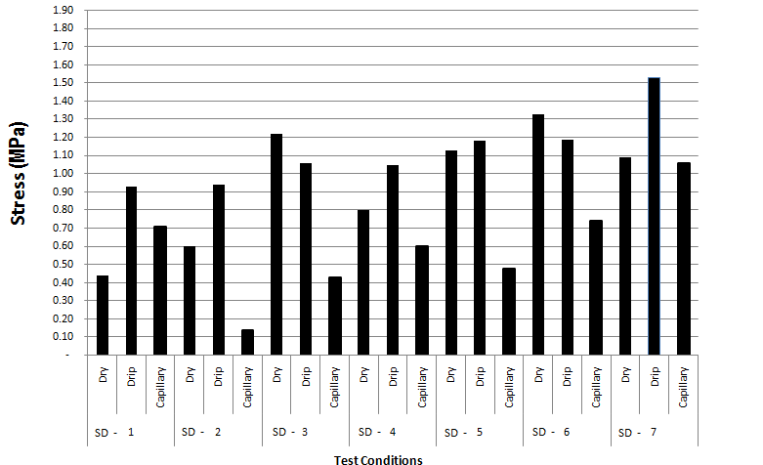
Fig. 1: Compressive strength test results of CEB and ACEB units vs. various testing condition [10]
The dry, post-drip and post-capillary absorption compressive strength test results with few anomalies are increasing gradually with somehow sustained values for series five (SD5), six (SD6) and seven (SD7). Referring to Figure 1 and taking the compressive strengths of SD6 and SD7 in reference to SD1 (soil only blocks-CEBs) the increments are: 207% (dry), 28% (post-drip), 6% (post-capillary) and 154% (dry), 63% (post-drip), 53% (post-capillary); respectively. This shows that, the method of amending the specific soil with the given additives has effectively improved, the strength and durability characteristics of the earth based building blocks.
In the capillary (flood simulation) monitoring case, percentage of the absorbed water through the exposed surface area was; 10.4% for series one, 2.6% for series two, 2.4% for series three, 2.1% for series four, 0.4% for series five, 0.6% for series six and 0.7% for series seven (Table 1). Though there are minor anomalies in the progressive improvement of water absorption of the amended compressed earth blocks as in ACEBs of series six (SD6) and seven (SD7), the anticipated positive result is achieved.
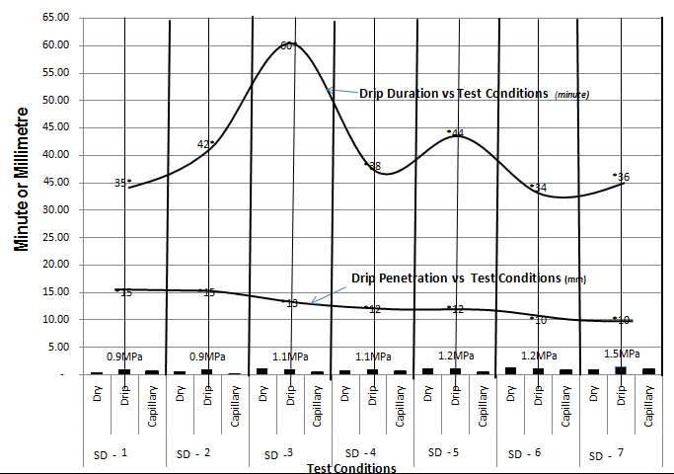
Fig. 2: Drip effect on CEB and ACEB units vs. various testing conditions [10]
The concept of amending natural soils was not from the wild but based on generations of old researches which noted: “Nearly, any soil can be made into a better building material with the addition of the CORRECT stabilizer” [16].This is a reminder of Sir Isacc Newton’s, “If I have been able to see a little further than some others, it was because I stood on the shoulders of giants”. It is an accepted universal truth in the world of scientific research and development [10].
At the most intensive stage of this research, as a blessing in disguise, though late for the country, the following two programs of rural housing development schemes were officiated by the government to address the dismal situation the target populous is in. A report on housing of MoUDHC (2014) notes: rural housing development is 3,400,000; urban including Addis Ababa is 1,500,000 [17]. Likewise, in the GTP II period, the Government of Ethiopia is planning to build 750,000 units in Addis Ababa only and 1.7 million housing units in rural development centers 2015/16 to 2020/21 [18]. In proportion of the rural to urban population it sounds reasonable to take the 3, 400, 000 rural households to predict the market share for this proposal. If the GTP II takes care of the 1.7 million there is still an equal amount in the years to follow. This of course is short of the new generation joining the growing housing demand; for there are always new families/households to come.
With the above in the background, it can be argued that the emergence of ACEB 565 as a viable building material will be an affordable candidate and a local popular technology to fill the gap by stepping in as an alternative to lime and cement stabilized products for the ambitious and yet huge rural housing development. The reality in here is that, all the raw materials are local and within reach. It doesn’t need any special skill to use. The most possible soil source for the block and mortar could even be the one excavated from the foundation of the house to be built on; as a best case scenario. Since the fresh blocks do not need water for curing it is a product with a lesser or of non-water demanding type. Blocks can be produced by the house owner. Building the house can be taken care of by the owner with very short term training. Re-use and re-cycling is easy at any moment and time. It conserves our non-renewable natural resources. The age long cultural self-help social practice can be a backbone to reduce the financial burden on the builder. A show case pilot project house was constructed at Buee TVET Technical College last year; which is 105 km from Addis Ababa and is under a monitoring scope for service time environmental effects.
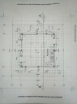
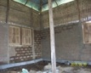
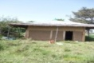
Fig. 3: The house (externally) Fig. 4: The Floor Plan Fig. 5: The house (internally)
In general, the proposed technology is eco-friendly in its entire life-cycle. Therefore, it is not erroneous to say that, this is an opportune moment to promote this patented product to a small scale industry through an appropriate housing development program. If done so, it will pave the way for a well founded social base change and an assured work opportunity for the graduates of every discipline of our universities at large; for it affects the inner most core life of the nearly 90 million people of Ethiopia; eventually. This is unimaginably colossal market for the generations to come; if supported with an appropriate research and development (R&D) inter-linked with community outreach.
This multi-faceted effort is a fertile ground of possible job creation for the graduates of our educational institutions from almost all disciplines of studies (science, engineering, agriculture, health sciences, social sciences, etc.); because the rural life style will change in many aspects which seriously requires the support and input of all professions. It will really herald a social renaissance in every aspect of ingenuity.
Fig. 6: The patent
The new product is mainly composed of: with the highest percentage of the soil to be used for the intended construction, lime as a basic ingredient, the highly abundant local pozzolans (volcanic ash, pumice, diatomite) in unilateral, bi-lateral or trio-proportions according to the need of the selected soil type to be amended. All are pulverized, properly and uniformly mixed and packed in powder form to the customer’s individual demand. Concise guidelines shall be issued to every customer to enable him/her use the ACEB 565 product in a proper, economical and effective technical way. Consultation invitations are welcome during the progress of the project at the expense of the concerned owner; if, wished so.
Moreover, a guide/book is under preparation to popularize the initiated effort as part and parcel of local construction materials development knowledge and keep abreast the Ethiopian society at large for its advancement. The inclusion of this finding into the construction industry primarily could have multi-dimensional advantages in the creation of job opportunities for our TVET and the like technical and vocational graduates. Including but not limited to: pulverizing and grinding machines, simple manual mixers and transporters, wooden and steel block casting forms/moulds and other hand tools, door and window crafting, etc. are among the many in the forefront. For sure, the future generations’ committed innovative effort would augment the list as a futuristic advancement of a home grown technology.
The trend in Ethiopia is signaling a fast population growth and the age group is tending towards the youth. This group of the society is full of energy which has to be dissipated or managed wisely guided by an inclusive national policy and an ultimate strategic plan. One of such possible field of engagements is a green rural, semi-rural and small towns’ real estate development which can further be fragmented into various modalities and specialties supported with an inclusive and pertinent micro-finance scheme. The package of low-cost housing will be earth based products; amongst which, ACEB will be one of the obvious and viable contenders.
Fig. 7: A process diagram showing ‘ACEB 565’ formulation, production and packaging
As a catalyst for the startup of small scale industry production of ACEB in its modest scale, the site plan in Fig. 8 shows what the plant components look like on a parcel of 3000m² land. The details: MS1-MS3 is open air storage for raw materials (scoria, pumice, diatomite, etc.); production unit/shade with a wide circulation space in between the two; towards the other end there are product store and office for the whole operation. It has to be clear that, there is no sophistication in the package of the setup. Since growth and development are the ultimate goal of any business entity, planning for future expansion is a plus for any eventuality.
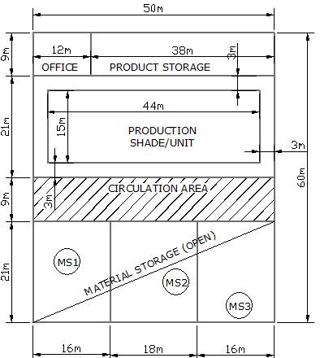
Figure 8: Production plant/unit component diagram

Conclusion and Recommendation
The objective of the research was to investigate the possibility of finding a local solution to the housing challenges of the rural and semi-rural community nation-wide focusing on natural soils and earth minerals. In order to un-ambiguously tackle the problem understanding the context was necessary to bridge the knowledge gap by consulting earlier works from scientific archives. The major lesson taken as the crux of the matter was the age long study finding which states that: “Nearly, any soil can be made into a better building material with the addition of the CORRECT stabilizer” [16]. The local raw materials found relevant were; natural soil, lime and a group of pozzolans. It was known that, lime impacts soil characteristics invariably. But, it lacks effectiveness to the anticipated degree for earthen construction. On the other hand, lime and pozzolans are ingredients in the production of cement; though at high kiln temperature. Going further, pozzolans are none reactive alone but could come to an excited state, if, powdered and combined with lime even at an ordinary room temperature in the presence of water; but feebly.
Thus, it was deduced that, since human beings are not strangers to soil (especially those in the rural areas), taking the abundant soil (at least for a while) as a major input and the remaining earth minerals as enhancers, the research was heated up and arrived at the following findings.
1. Understanding that natural soils are of varying compositions the quest to generalize and substantiate the move as conclusive is yet. With that in mind, the initiated effort and the finding there of indicated that amending a given soil with the mentioned earthly minerals has confirmed a gain in compressive strength as referred to established world class standards of ARSO, New Zealand and New Mexico.
2. Since earthen constructions are prone to water attack the drip and capillary absorption tests confirmed that the resistance gained through amending unquestionably met the African Regional Standards Organization (ARSO) and New Zealand standards for durability.
3. In a nut shell, the initiated move towards finding an environmental friendly, affordable, sustainable and a reliable shelter construction material for the have-nots is found to be a worthwhile alternative to alleviate the persistent housing soaring demand for the rural and semi-rural segment of the society.
Recommendation
Having the awareness that, as time is speeding up, we, Ethiopians can’t remain aloof by standers; it surely is a critical moment to realize the following to embark on a well founded futuristic and innovative housing scheme by 2050. Towards achieving that, the following need be accomplished hand in hand and with a strong dedication.
a. Let’s keep the huge rural population in our national strategic scope in its entirety of livelihood transformation (not with segmental and rudimentary actions).
b. The housing construction input which is found with the help of this research need be taken seriously as an alternative to its similar contenders to redress the huge housing backlog and the social neglect.
c. Our design and construction standards must encompass the local housing base as done in Nepal; adding up voluntary codes as well.
d. Our universities and research centers must take such basic problem solving initiatives focusing on the future crucial challenges of the nation and the environment.
e. Many African countries have adopted standardized earthen construction and are members of ARSO. The name of Ethiopia is also in the list of ARSO members represented by the then Quality and Standards of Ethiopia (QSAE); but actions are not on the ground. Let’s give it a life.

References
[1]. Jaime Cid-Falceto, Pablo Mosquera, Fransisco Marcos, Cruz Calleja Perucho, Ignacio Cańas, “Approximation to Earth Material from International Normative”, NBR 10832:1989: NZS 4299:1999. NBR 10833: 1989: … NBR 13555: 1996, jaime.cid@upm.es.
[2]. Asmamaw Tadege and Abebe Dinku (2003), Study of Compressed Cement Stabilized Earth Blocks As An Alternative Wall Making Material, EACE Journal, Vol. 4, December 2003.

[3]. A.B. Ngowi (1997), Improving, the Traditional Earth Construction: a case study of Botswana, 1997.

[4]. E.A. Adam and A.R.A. Agib (2001), Compressed Earth Block Manufacture in Sudan, UN Education, Scientific and Cultural Organization, Paris, July 2001.

[5]. Mohammed Sharif Zami and Angela Lee (2011), Economic Benefit of Contemporary Earth Construction in Low-Cost Urban Housing-State-of-the Art Review, Journal of Building Appraisal (2011), Vol. 5, 259-271.

[6]. Woubishet Zewdu Taffese and Kassahun Admassu Abegaz (2019), Embodied Energy and CO2 Emission of Widely Used Construction Materials: The Ethiopian Context, Buildings 2019, 9, 136, 1-15; doi: 10.3390/buildings 90601.36.
[7]. ASTM C 952-12, Standard Test Method for Bond Strength of Mortar to Masonry Units.

[8]. Lorenzo Jurina, Morinca Righetti, Traditional Building in Peru.

[9]. Ram Chandra Kandel (2008), “Bottom-up Approach for Building Code Implementation in Nepal”, the 14th World Conference on Earthquake Engineering, October 12-17, Beijing.
[10]. Kassahun Admassu Abegaz (2019), Use of Amended Soils for Compressed Block and Mortar in Earthen Construction, Journal of EEA (Zede), Annual Publication of the Addis Ababa Institute of Technology (AAiT)/AAU, Vol. 37, 69-84, July 2019.
[11]. Lars Holmgren, “Some Experiments on Stabilized Soil Blocks”, Haile Selassie I University, Building Centre, Addis Ababa, Report No.2, 1964.
[12]. Franco Massazza (1976), Chemistry of Pozzolanic Additions and Mixed Cements, “Principal paper” presented to the VI International Congress on the Chemistry of Cement (Moscow, September 1976).

[13]. Lyle A. Wolfskill, Wayne A. Dunlop, Bob M. Callaway (1981), Handbook for Building Homes of Earth, 1981.

[14]. New Mexico Earthen Building Materials Code (2004), Construction Industries Division of the Regulation and Licensing Department; November 19, 2004.

[15]. Adam Davis Krosnowiski (2011), A proposed Best Practice Method of Defining a Standard of Care for Stabilized Compressed Earth Block Production, April 2011.

[16]. V. Maniatidis and P. Walker (2003), Review of Rammed Earth Construction, May 2003.

[17]. MoUDHC (2014), National Housing Development Policy and Strategic Framework.

[18]. Pillars, Programs and Projects that support achievement of Ethiopian Cities Sustainable Prosperity Goals (ECSPGs) (2015/16 -2024/2025); (2015). Growth and Transformation Plan II (GTP II), Ministry of Urban Development and Housing.

